Database Design
Contents
User and related tables 2
Product and related tables 3
Screen and related tables 4
Field and related tables 6
Tables Description 8
System tables 8
Product & related tables 13
Screen and related tables 15
Field and related tables 17
Stored Procedure 20

User and related tables
See below for Key information
- A User has ONE Role
- A Role has MANY Users
- A User is belong to MANY Groups
- A Group has MANY Users
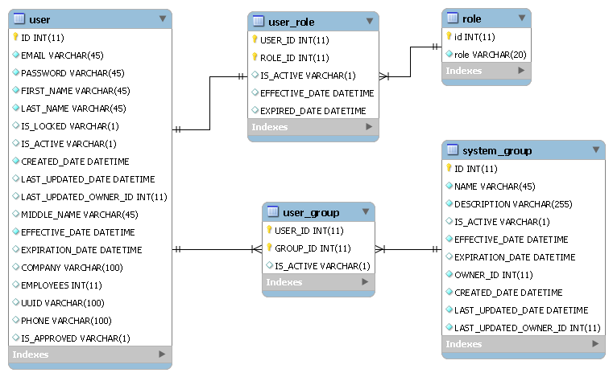

Product and related tables
See below for Key information
- A Product has MANY Versions
- A Product has MANY Tags
- A Product can be access by MANY Groups
- A Product has MANY Custom Fields
- A Product Version has MANY Documents
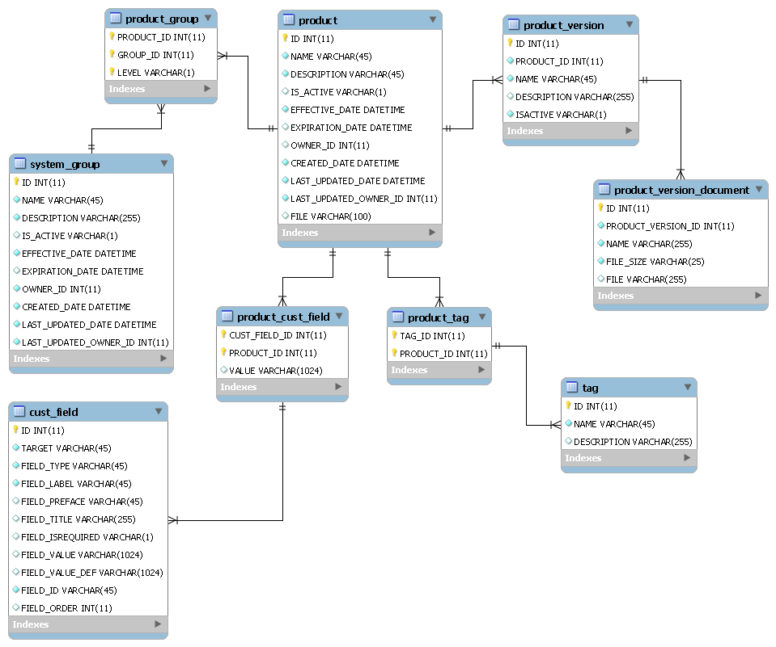

Screen and related tables
See below for Key information
- A Screen has MANY Tag
- A Screen can be accessed by MANY Groups
- A Screen has MANY Custom Fields
- A Screen has MANY Documents
- A Screen has MANY Events
- A Screen has MANY Parent Screens
- A Screen has MANY Messages

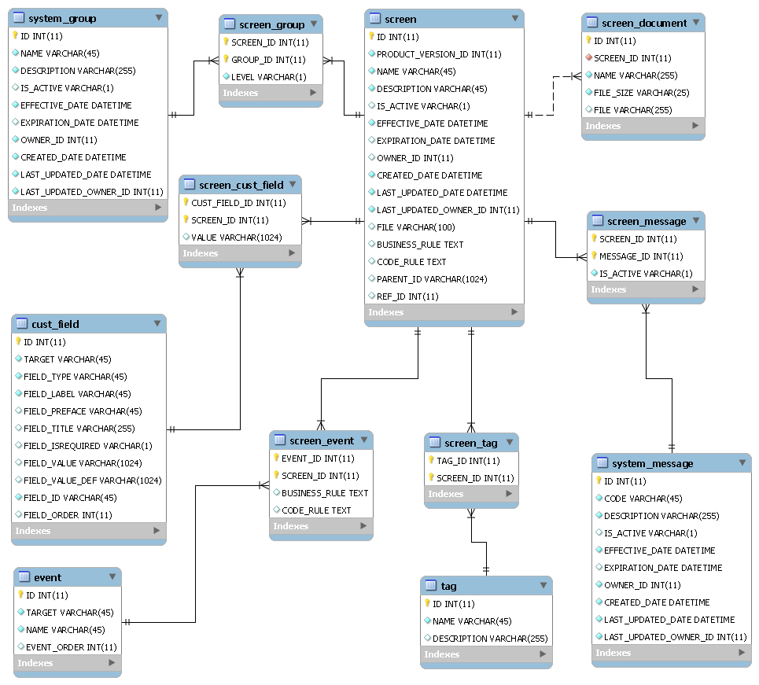

Field and related tables
See below for Key information
- A Field has MANY Tag
- A Field can be accessed by MANY Groups
- A Field has MANY Custom Fields
- A Field has MANY Documents
- A Field has MANY Events
- A Field has MANY Dependent Fields
- A Field has MANY Messages

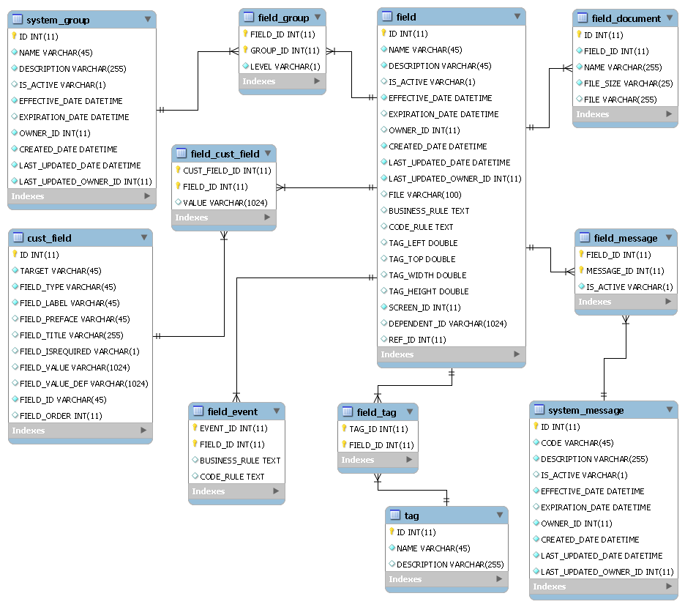

Tables Description

System tables
ROLE
This is to store all Roles
Id
Role | There are 3 roles in Field Catalog system.  It can be Admin, Designer and Viewer.

USER
This is to store all Users
ID
EMAIL
PASSWORD
FIRST_NAME
LAST_NAME
IS_LOCKED
IS_ACTIVE
CREATED_DATE
LAST_UPDATED_DATE
LAST_UPDATED_OWNER_ID
MIDDLE_NAME
EFFECTIVE_DATE
EXPIRATION_DATE
COMPANY
EMPLOYEES
UUID
PHONE
IS_APPROVED

SYSTEM_GROUP
This is to store all Groups
ID
NAME
DESCRIPTION
IS_ACTIVE
EFFECTIVE_DATE
EXPIRATION_DATE
OWNER_ID
CREATED_DATE
LAST_UPDATED_DATE
LAST_UPDATED_OWNER_ID

USER_GROUP
This is to store relationship MANY TO MANY between USER and GROUP

USER_ROLE
This is to store relationship MANY TO ONE between ROLE and USER

CUST_FIELD
This is to store all Custom Fields which Admin created dynamically. These custom fields are used for Product, Screen and Field.
ID
TARGET | It can be Product, Screen or Field
FIELD_TYPE | It can be a Text Input, Text Input Area or Check Box …
FIELD_LABEL
FIELD_PREFACE
FIELD_TITLE
FIELD_ISREQUIRED
FIELD_VALUE | This is to keep values for custom fields such as a list of values for a Drop down.
FIELD_VALUE_DEF
FIELD_ID
FIELD_ORDER | This is to keep display order of a custom fields on Product, Screen or Field page.

TAG
This is to store all Tags
ID
NAME
DESCRIPTION
SYSTEM_MESSAGE
This is to store all Messages
ID
CODE
OWNER_ID
IS_ACTIVE
DESCRIPTION
EFFECTIVE_DATE
EXPIRATION_DATE
CREATED_DATE
LAST_UPDATED_DATE
LAST_UPDATED_OWNER_ID

EVENT
This is to store all Events which Admin created dynamically. These events are used for Screen and Field.
ID
TARGET
NAME
EVENT_ORDER

Product & related tables
PRODUCT
This is to store all products
ID
NAME
DESCRIPTION
IS_ACTIVE,
EFFECTIVE_DATE
EXPIRATION_DATE,
OWNER_ID
CREATED_DATE
LAST_UPDATED_DATE
LAST_UPDATED_OWNER_ID
FILE

PRODUCT_VERSION
This is to store all Versions of Products

PRODUCT_CUST_FILED
This is to store relationship MANY TO MANY between PRODUCT and CUST_FIELD

PRODUCT_DOCUMENT
This is to store relationship ONE TO MANY between PRODUCT and DOCUMENT

PRODUCT_EVENT
This is to store relationship MANY TO MANY between PRODUCT and EVENT

PRODUCT_GROUP
This is to store relationship MANY TO MANY between PRODUCT and GROUP

PRODUCT_TAG
This is to store relationship MANY TO MANY between PRODUCT and TAG

Screen and related tables
SCREEN
This is to store all screens
ID
NAME
DESCRIPTION
IS_ACTIVE
EFFECTIVE_DATE
EXPIRATION_DATE
OWNER_ID
CREATED_DATE
LAST_UPDATED_DATE
LAST_UPDATED_OWNER_ID
FILE
BUSINESS_RULE
CODE_RULE
PARENT_ID | This is to store a list of parent screen id(s) of this screen.
REF_ID | This is to keep an original id of a screen which is the source of the clone product.

SCREEN_CUST_FILED
This is to store relationship MANY TO MANY between SCREEN and CUST_FIELD

SCREEN_DOCUMENT
This is to store relationship MANY TO MANY between SCREEN and DOCUMENT

SCREEN_EVENT
This is to store relationship MANY TO MANY between SCREEN and EVENT

SCREEN_GROUP
This is to store relationship MANY TO MANY between SCREEN and GROUP

SCREEN_TAG
This is to store relationship MANY TO MANY between SCREEN and TAG

SCREEN_MESSAGE
This is to store relationship MANY TO MANY between SCREEN and MESSAGE

Field and related tables
FIELD
This is to store all fields
ID
NAME
DESCRIPTION
IS_ACTIVE
EFFECTIVE_DATE
EXPIRATION_DATE
OWNER_ID
CREATED_DATE
LAST_UPDATED_DATE
LAST_UPDATED_OWNER_ID
FILE | This is an image file name which is stored in data folder in web server.
BUSINESS_RULE
CODE_RULE
TAG_LEFT, TAG_TOP, TAG_WIDTH, TAG_HEIGHT | These are properties to store Left, Top, Width and Height of a field which is tagged on a screen image.
SCREEN_ID
DEPENDENT_ID | This is to store a list of dependent id(s) on other fields.
REF_ID | This is to keep an original id of a field which is the source of the clone product.

FIELD_CUST_FILED
This is to store relationship MANY TO MANY between FIELD and CUST_FIELD

FIELD_DOCUMENT
This is to store relationship ONE TO MANY between FIELD and DOCUMENT

FIELD_EVENT
This is to store relationship MANY TO MANY between FIELD and EVENT

FIELD_GROUP
This is to store relationship MANY TO MANY between FIELD and GROUP

FIELD_TAG
This is to store relationship MANY TO MANY between FIELD and TAG

FIELD_MESSAGE
This is to store relationship MANY TO MANY between FIELD and MESSAGE

Stored Procedure
Stored Procedure
checkIfCustFieldUsed | This is to check if a custom field is used.  It is used when a custom field is going to be deleted.
checkIfGroupUsed | This is to check if a group is used.  It is used when a group is going to be deleted.
checkIfEventUsed | This is to check if an event is used.  It is used when an event is going to be deleted.
checkIfMessageUsed | This is to check if a message is used.  It is used when a message is going to be deleted.
checkIfUserUsed | This is to check if a user is used.  It is used when a user is going to be deleted.
cloneFieldsByScreenId | This is to clone all fields of a screen. It is used from cloneProductVersion.
cloneProductVersion | This is to clone a product version to another version. It will clone all screens and fields.

Setup Scripts
Entire script and updated version can be found at SourceForge or GitHub under FieldCatalog project.
I also attached that script at here.

